**Database Feedback 11/18/16 from Cristi**

**CERTIFIED PERSONS TAB**

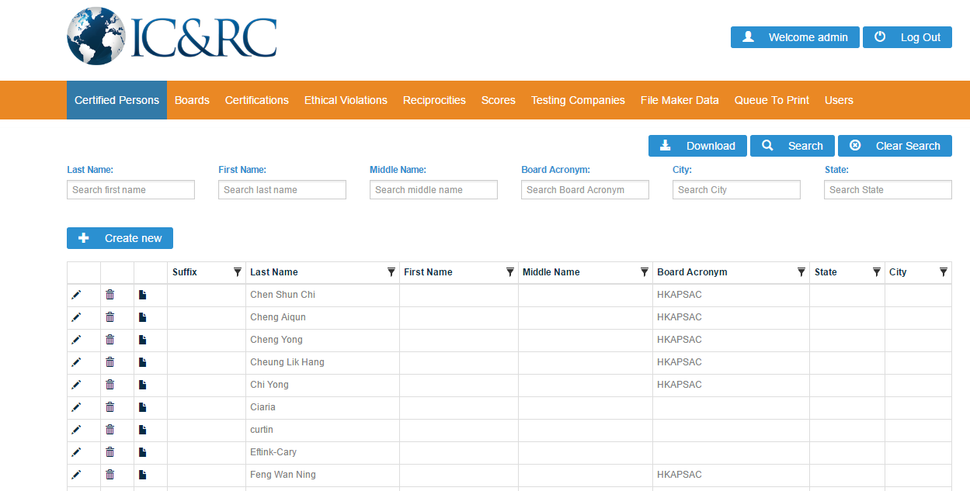

* Love the new search feature but consider note from body of email regarding uniform fields for searching.
* Can we move the DOWNLOAD button to the right of CLEAR SEARCH?

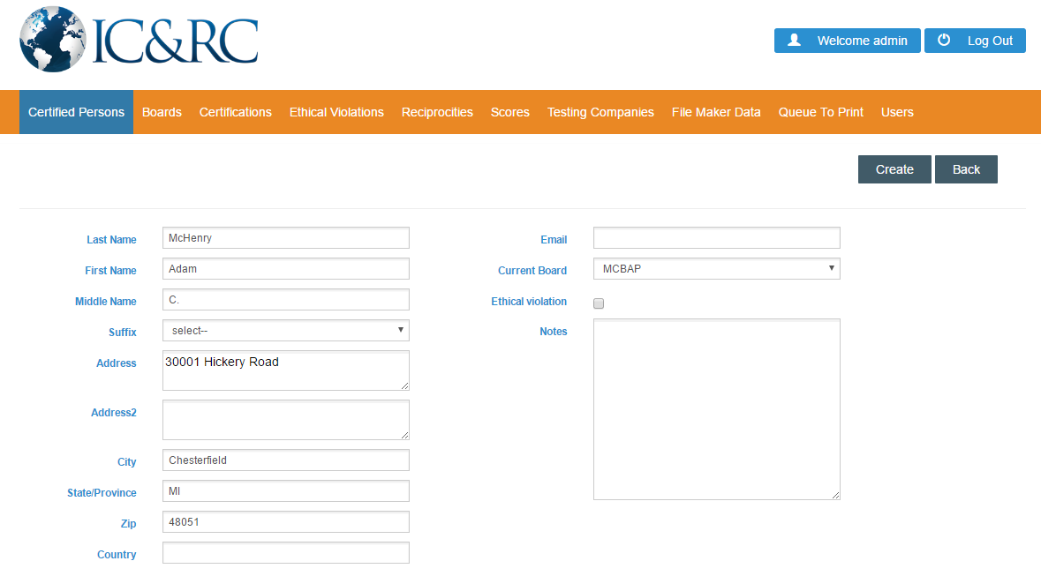

* The drop down of suffixes holds prefixes. This drop down should include Sr., Jr., I, II, III and then an option for free text just in case we need to certify Loui XIV :P
* As described in the body of the email, this information being separate from the “certifications” tab is not very intuitive. When creating a new record, it would be helpful if the following data could also be entered on this screen:
  + Certificate number (auto generated)
  + Certification (eg., ICADC, ICAADC)
  + Certificate issued date
  + Expiration date
  + Board’s certificate acronym
  + Plus payment information
    - Certificate request date
    - Payment type
    - Payment number
    - Certificate request fee
    - Add to print queue

PROBLEM ENCOUNTERED:

* Under CERTIFIED PERSONS, I created a new record for Adam McHenry.
* When I searched for Adam McHenry, I found three records.
* When I clicked on the edit tool, I got this message (I get the same message when I click on the details icon):

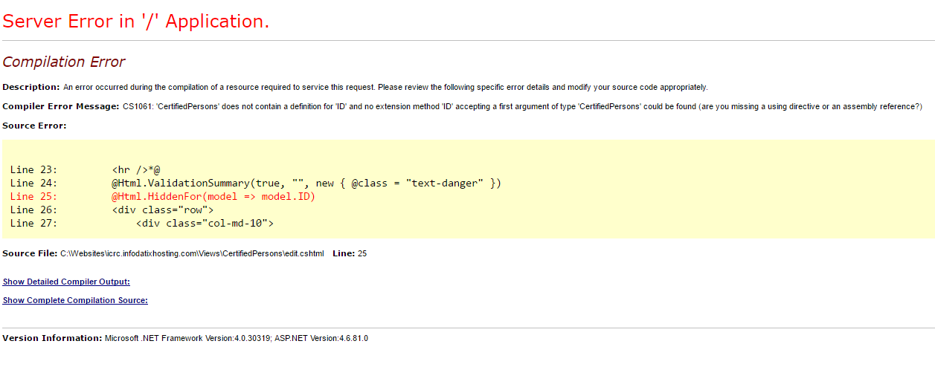

**CERTIFICATIONS TAB**

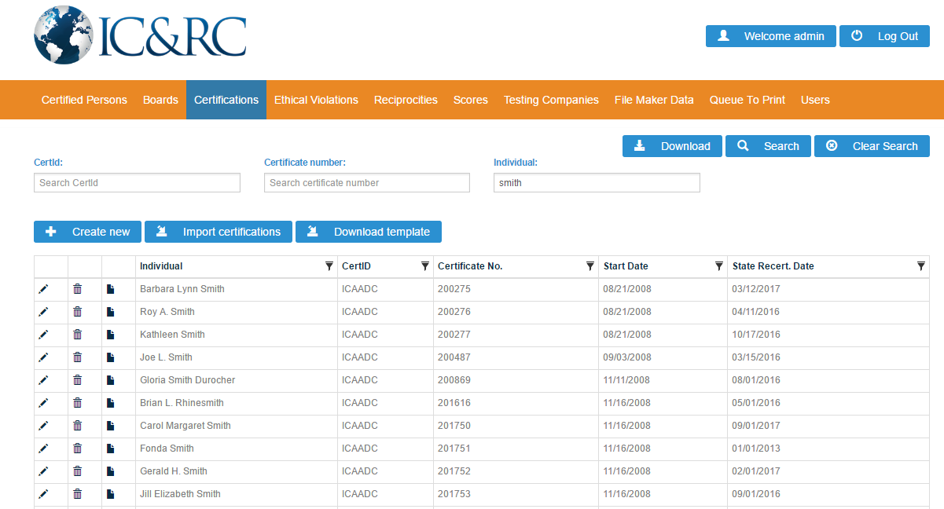

* As described in body of email, we’d like the individual’s name broken into three fields (first, MI, last) instead of combined. It’s difficult to look up an individual this way. For instance, if I look up Roy Smith, nothing shows up. I’d have to know the professional’s name is Roy A Smith.
* In addition to the search fields of CertID and Certificate number, search feature should include Last name, first name, middle name, and board acronym.

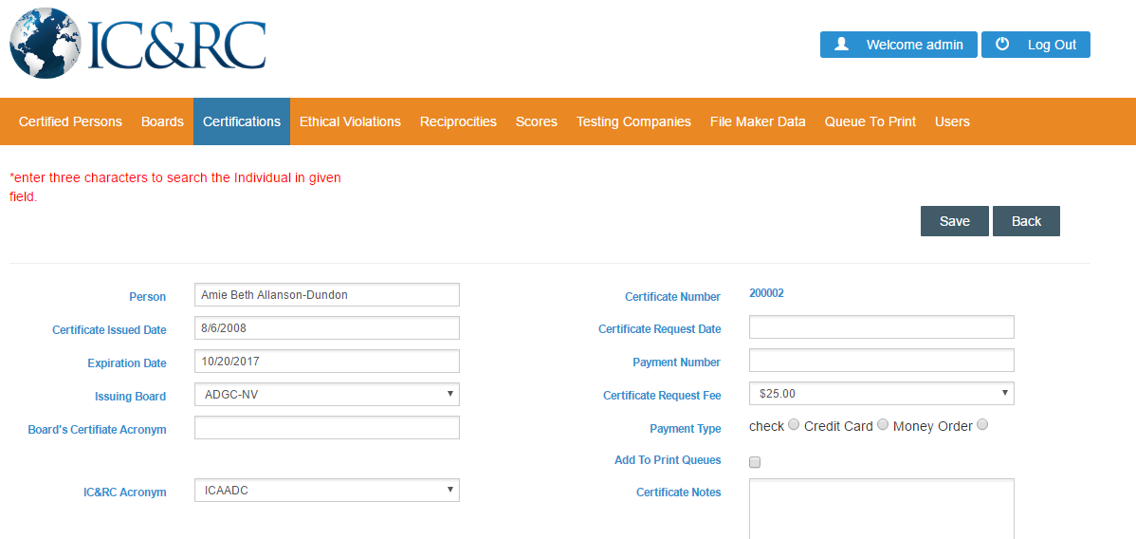

* Minor request: Would you please capitalize the “c” in “check” under payment type?

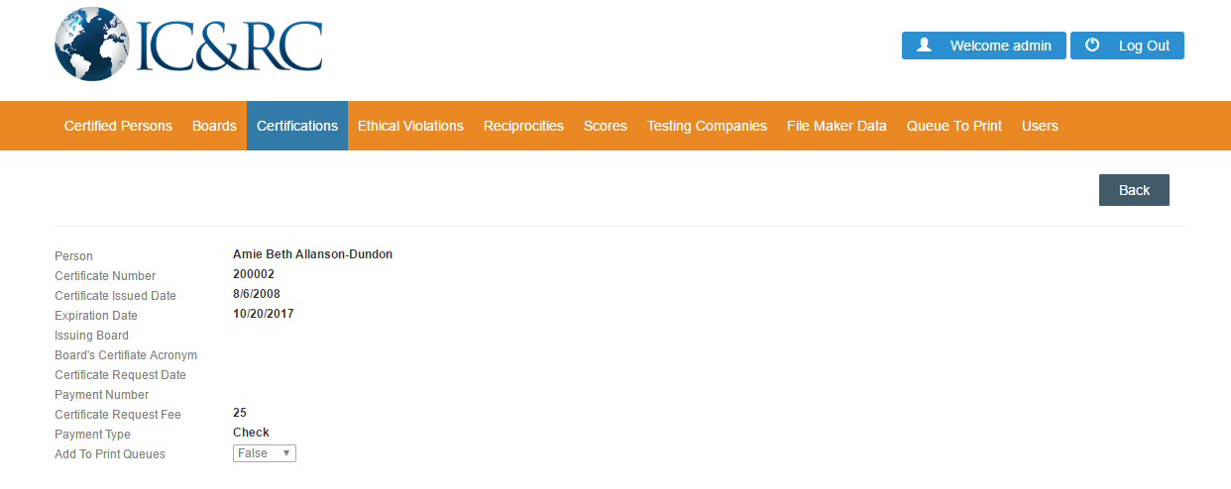

* This screenshot is reached by clicking on the detail view.
* Note the board does not populate, but it does when looking in the edit view.

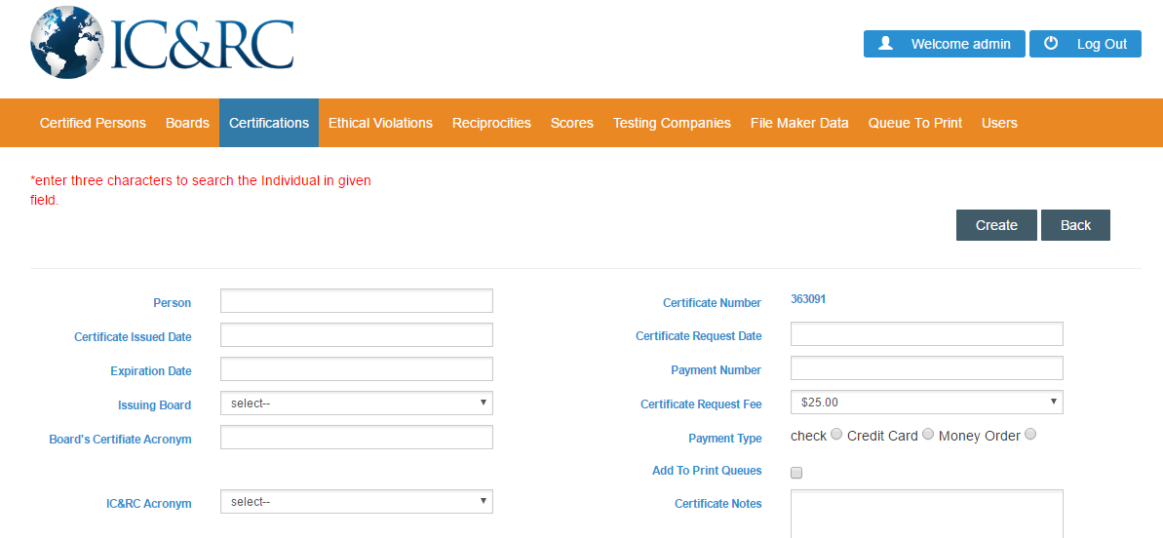

* This screenshot is reached by clicking on the CREATE NEW button.
* Name fields should be separated into first name, middle initial, last.
* Problematic layout. What if there are two John Smiths from New York? There’s no way to differentiate who this individual is.
* I’d prefer to see this data entry point under CERTIFIED PERSONS to make for easier data entry.

**ETHICAL VIOLATIONS**

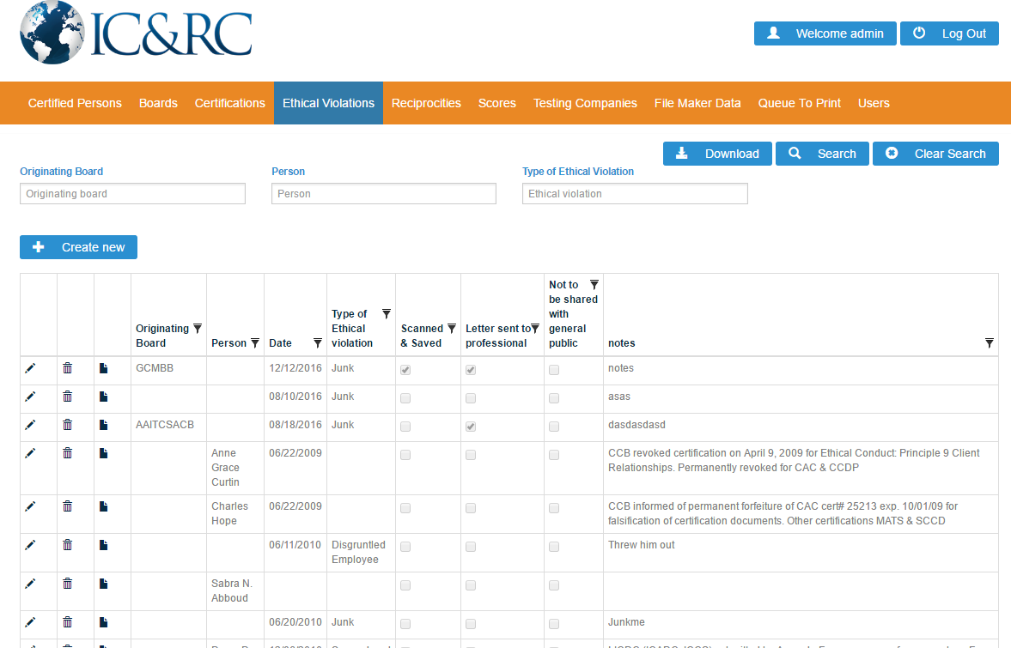

* To be more effective, the search feature needs to be broken down into: First name, middle initial, last name, originating board, type of ethical violation. As currently stands, in order to search for the professional, you have to know the person’s complete name, which is impractical if they have a common name.
* Please widen the column for the person’s name.
* The person’s name should be the first column.

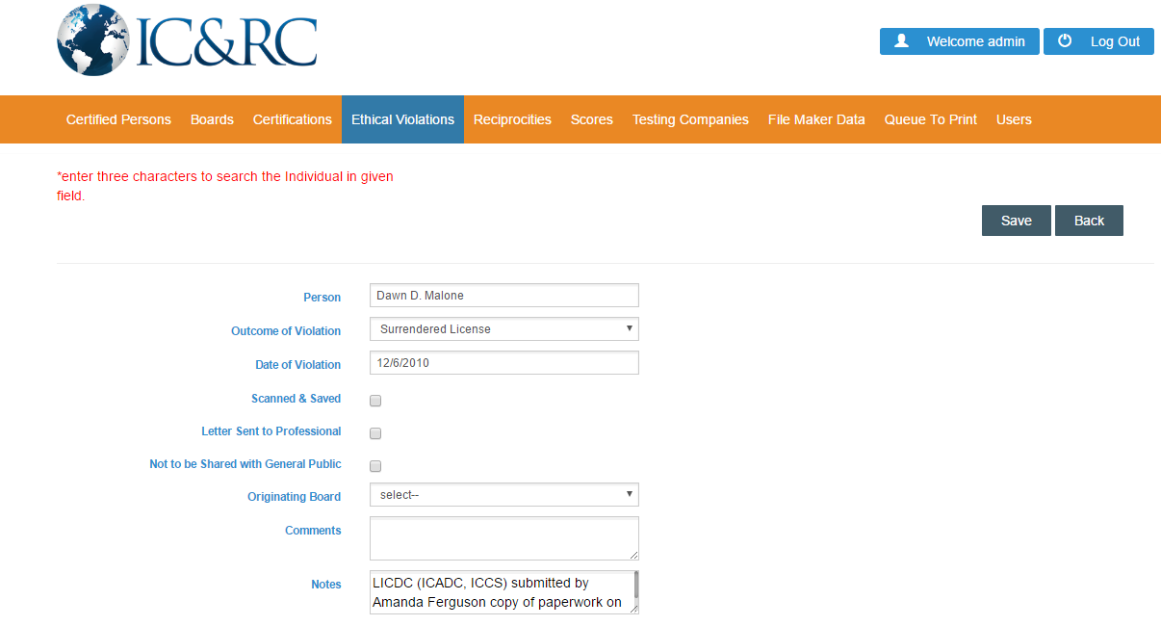

* Screenshot reached through the editing tool.
* There needs to be a way of entering a different kind of ethical violation. How do we add types of OUTCOME OF VIOLATION data?
* Originating Board data should transfer; currently, the field is empty.
* “Comments” and “Notes” is duplicative. Eliminate “Comments.”
* Enlarge the “Notes” box.